**Employee Application** :

Step:1 Access depart page url: <http://localhost:8080/EmployeeApp/krams/main/record/list>

[Get Employee List with Departments](http://localhost:8080/EmployeeApp/krams/main/record/list) : Fetch all employees associated with departments.

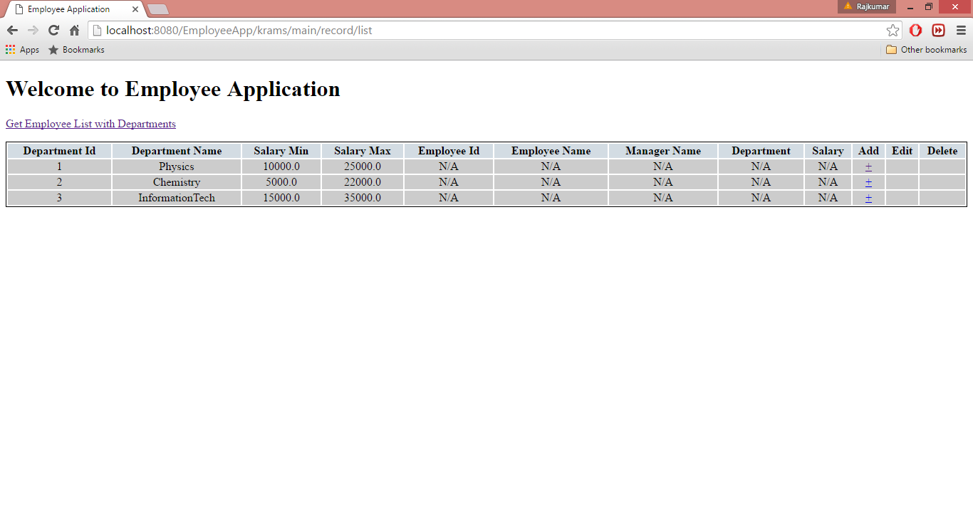

Step: 2 Adding new Employee

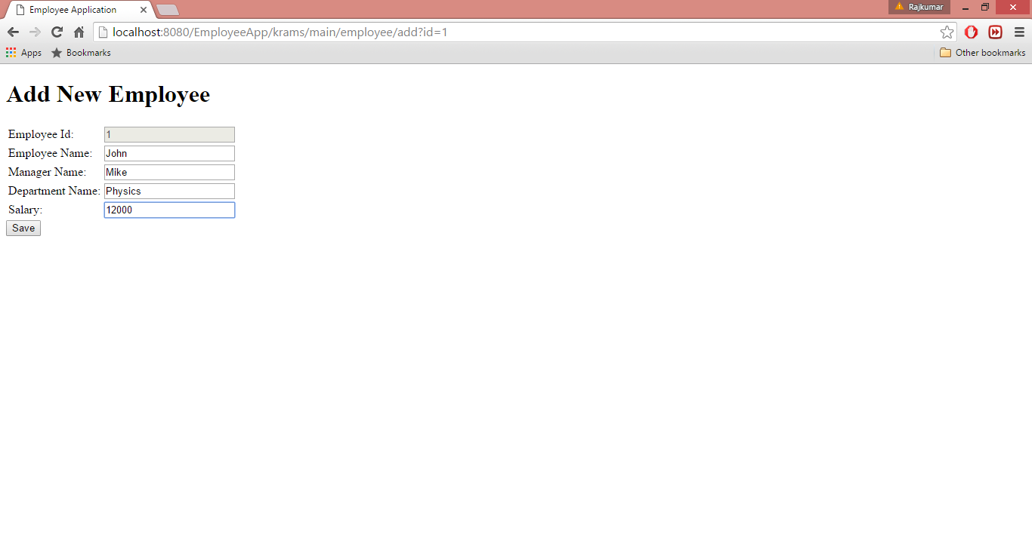

Step :3 Validation while adding employee

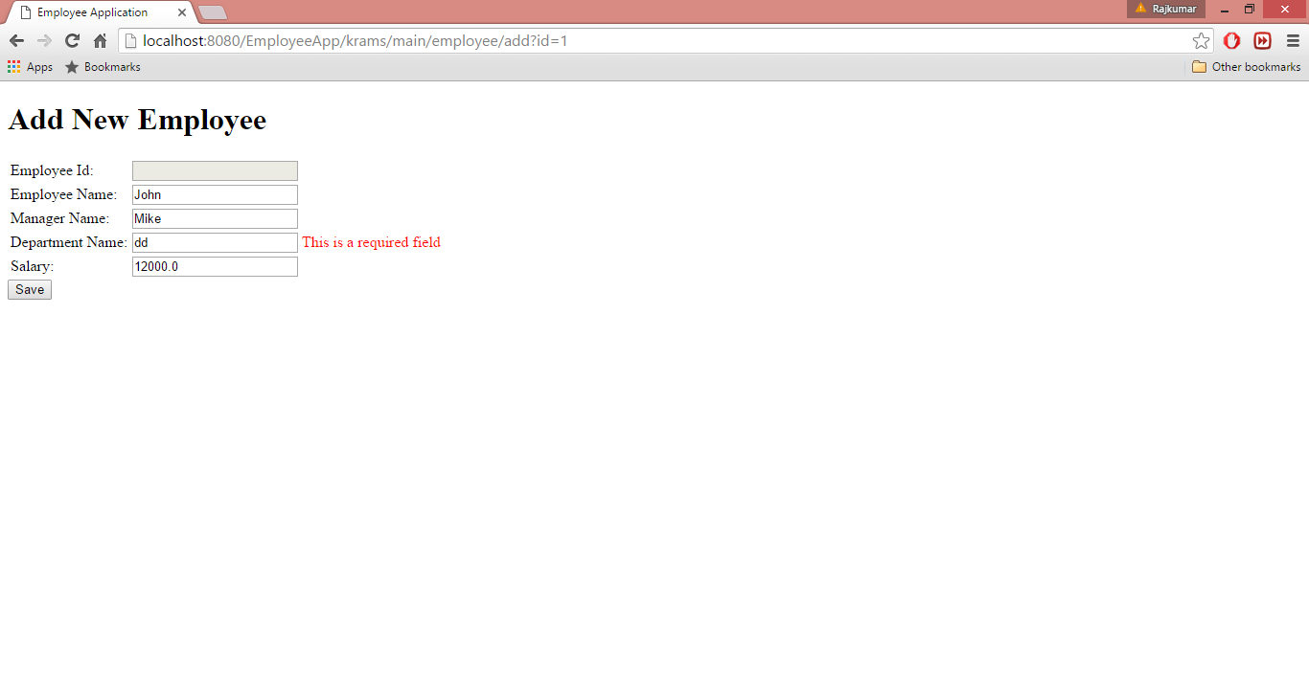

Step :4 Validating department and salary with department application

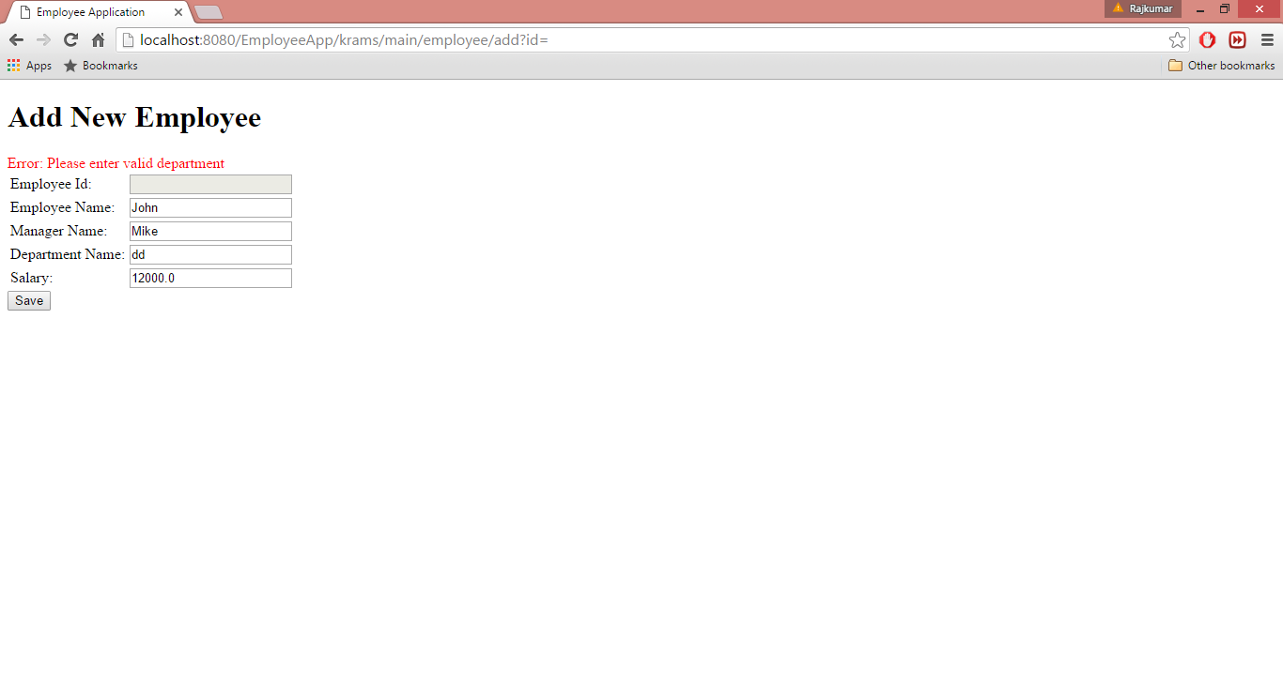

Step :5 Adding new employee

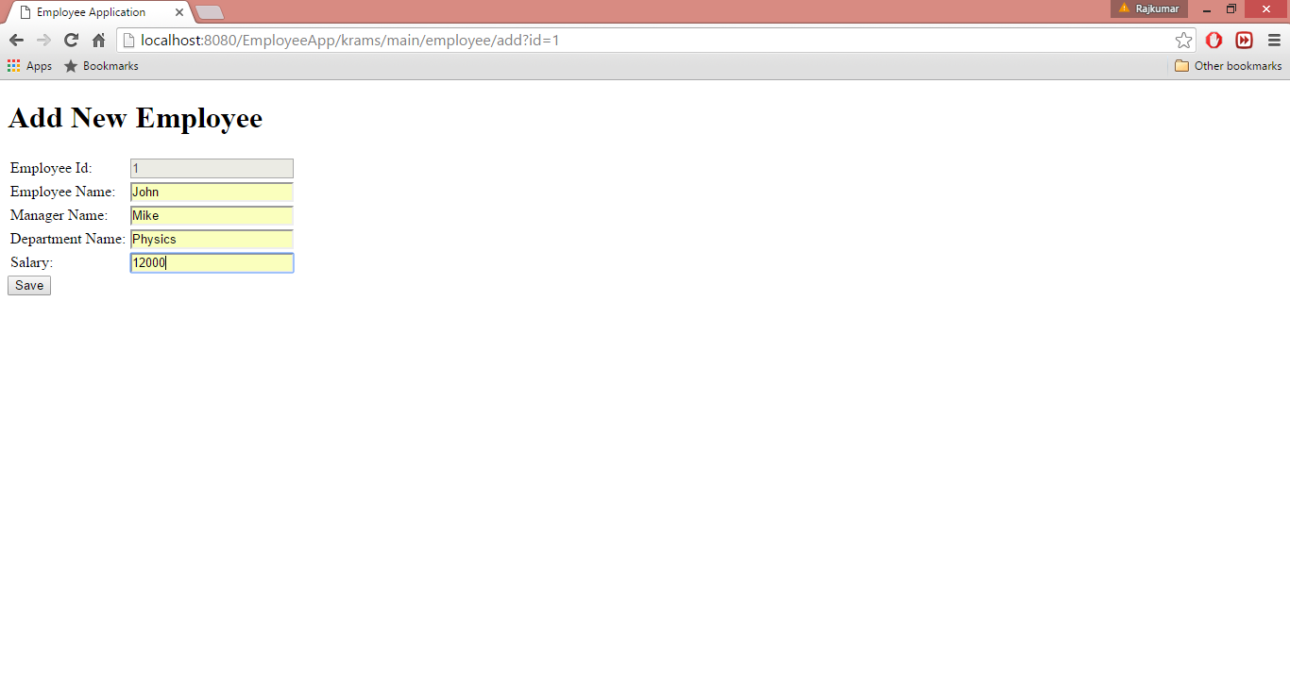

Step : 6 Display Added employee on employee detail screen

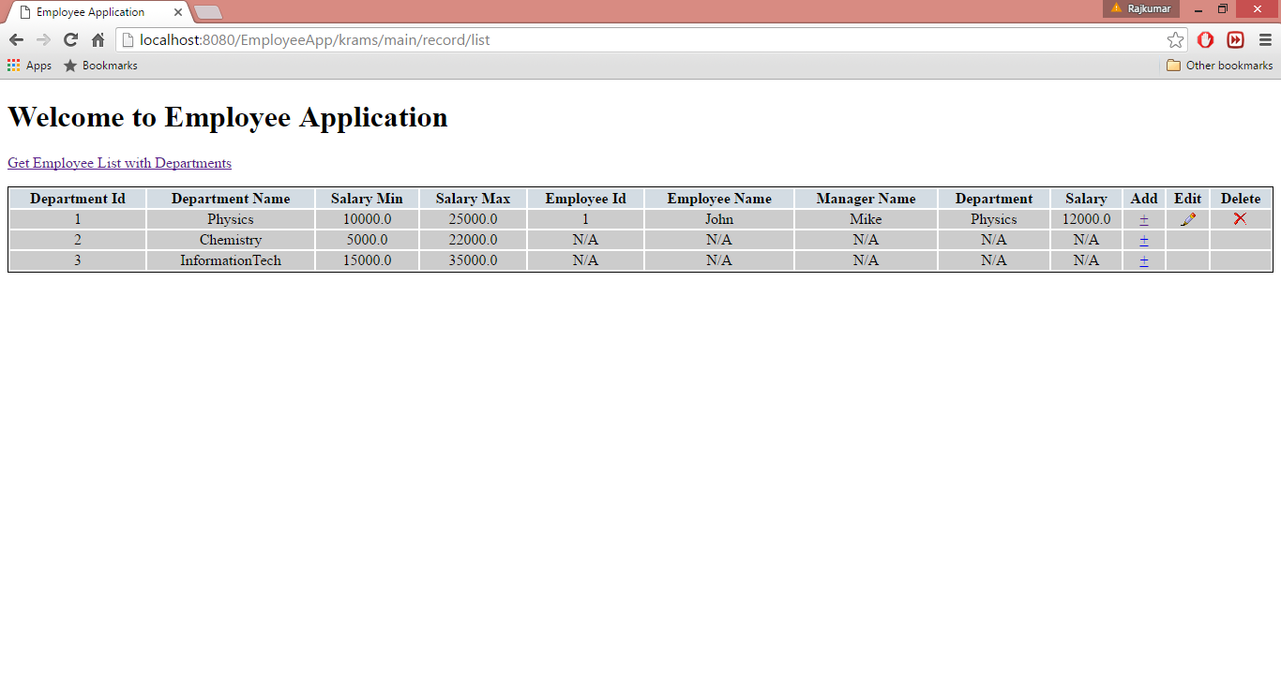

Step : 7 Validation on Edit Screen

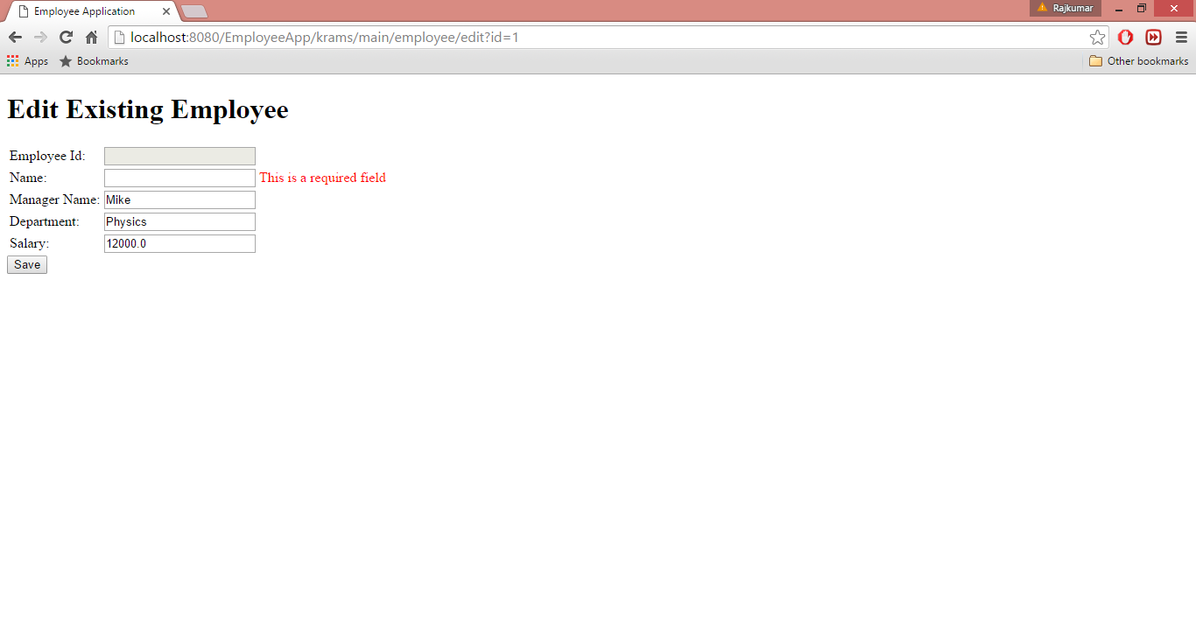

Step :8 Editing existing empoyee

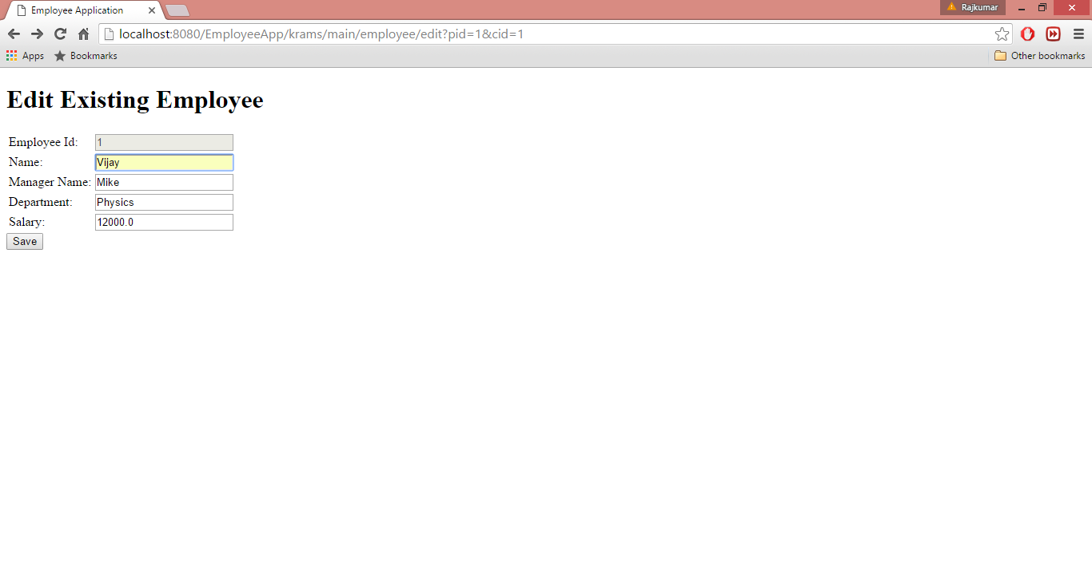

Step 9: Updated employee details

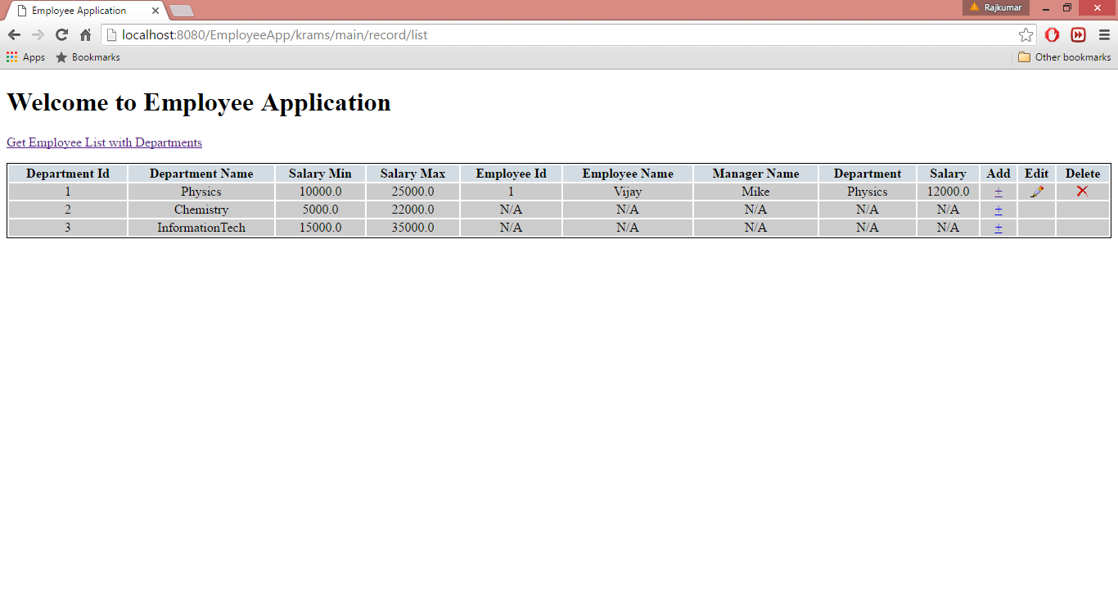

Step 9: Delete employee details

